Irma Voth by Miriam Toews  The stifling Mennonite life of nineteen-year-old Irma Voth - newly married and newly deserted - is irrevocably changed when a film crew moves in to make a movie about her community. She wants to embrace the creative passion of their world, but her intractable father is determined to keep her from it. The confrontation between them causes her and her young sister, Aggie, to flee to the city, even as they begin to understand the tragedy that has their family in its grip.  Important note: This DAISY talking book plays on DAISY talking book players and software.    Navigation tip: An explanation of the navigation structure of this book is found in “About this DAISY talking book” at the beginning of Level 1. | Irma Voth by Miriam Toews | Irma Voth by Miriam Toews  Narrator: Sondra Bolton  Toronto: A.A. Knopf, 2011  1 CD (6hrs., 30 min.)  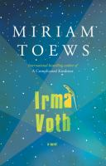  This material is for the exclusive use of persons unable to read print because of a perceptual disability as defined by the Canadian Copyright Act.  

